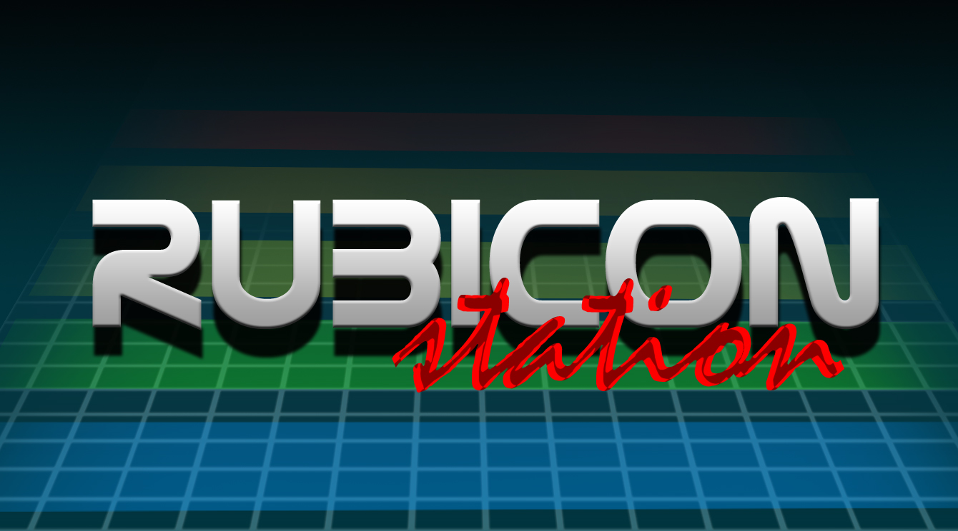
Project Name
The ACM Arcade Machine (RUBICON Station)

Project Manager
Frank Lima

Project Definition
To create an open source based tabletop arcade machine with fully functional controls and interface.

Project Scope
To create an arcade machine using MDF particle wood, using retro equipment such as joysticks and monitors from the 80's era. Running using open source software under $200 in cost.

Project Goals
- To understand and implement the creation of an arcade cabinet
- To implement ATX hardware within the cabinet formfactor
- To use and coordinate Linux software to run on an arcade monitor (320x240 display)
- To configure a useable and updatable interface to allow the installation of entertainment software

Project Dependencies
- Wood working materials and tools
  - Table saw
  - Drills
  - Wood
  - Drill bits
  - Screws
  - Plexi Glass
  - Wood Glue
  - Wood Filler
  - Epoxy
  - Paint (Black)
  - Sand Paper
  - Sander
  - Workshop masks

- Technical Hardware
  - ATX Motherboard (AMD Socket 462)
  - AMD CPU Socket 462
  - Hard Drive > 10GB
  - Video Card with S-video out
  - Power Supply
  - 1/8th inch audio cable to RCA
  - 12 inch arcade cabinet monitor
  - arcade joysticks
  - arcade buttons
  - Power strip
  - wiring
  - solder
  - soldering iron
  - USB keyboard

- Other
  - Printed logo
  - Linux Distribution

Project Team
- Frank Lima
- Roscoe Reed
- Nathan Pickrell
- Natalie Xavier
- Joe Smith
- Luci Smith

Project Stakeholders
- To all who wish to use the arcade machine
  - ACM members
  - Fellow CECS majors
  - and more!

Project Phases
- PHASE 1 – Planning and Computer Aided Design
  - This stage we will plan the physical design and requirements of the arcade machine, including materials and size requirements for hardware.
- PHASE 2 – Construction
  - We will use the wood working shop located at Frank's house to construct the external cabinet in three phases
    - Phase 1 – Bottom portion
    - Phase 2 – Side Walls
    - Phase 3 – Top and Front
  - Then we will sand and paint the exterior with a jet-black paint
- PHASE 3 – Hardware
  - At this stage we will be putting in the ATX based hardware and monitor inside of the cabinet and ensuring that there is proper ventilation for the hardware as well as fitting in the lighting for the front panel
- PHASE 4 – Playing Board and wiring
  - This is where the playing board is put together and the wiring is set in place for the controls, sound, power button and other peripherals.
- PHASE 5 – Testing
  - This is the final phase, to test for any hardware and software errors and implement the arcade machine.

Project Timeline
- PHASE 1: 12-01-10 to 12-15-10
- PHASE 2: 12-16-10 to 01-15-11
- PHASE 3 – 01-16-11 to 02-10-10
- PHASE 4 – 02-11-11 to 03-25-11
- PHASE 5 – 03-26-11 to 04-01-11

Project Challenges
- Due to the limitation of wood working hardware, the accuracy in which the arcade will be assembled will not be high.
- Also due to the nature of the hardware of the machine, finding the necessary parts and funds may be hard to come by.

